Project Development Phase

Sprint 2

|  |  |
| --- | --- |
| **Date** | **17 November 2022** |
| **Team ID** | **PNT2022TMID40645** |
| **Project Name** | **Digital Naturalist - AI Enabled Tool For Biodiversity Researchers** |
| **Maximum Marks** | **4 Marks** |

1. **Indexing disaster classes**

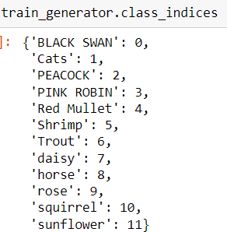

1. 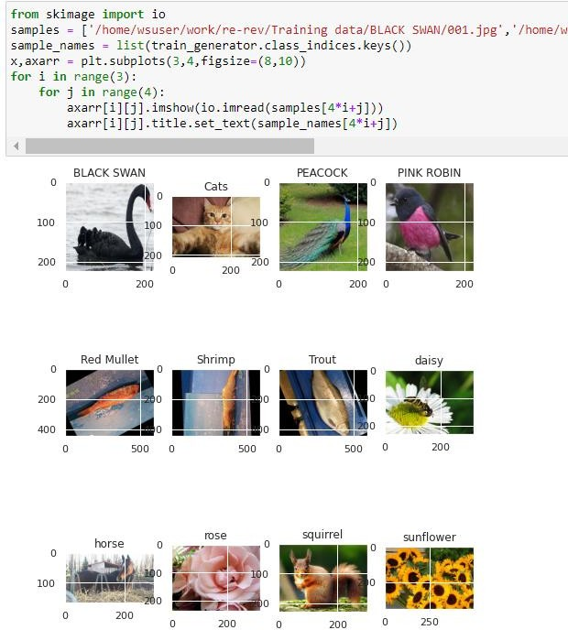**Sample Plot for each classes**
2. **CNN Model architecture and Compilation using Adam Optimizer**

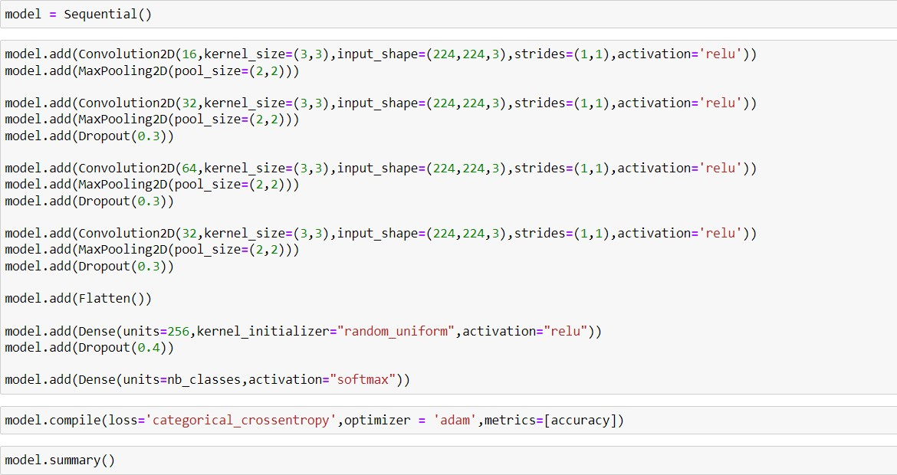

1. **Summary of Model**

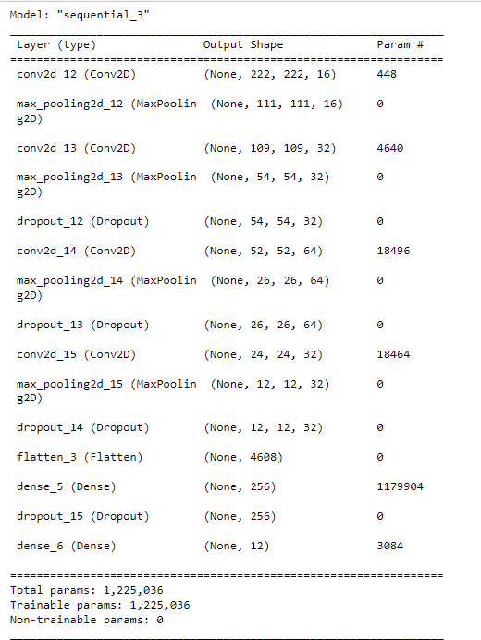

1. **Training and Validation**

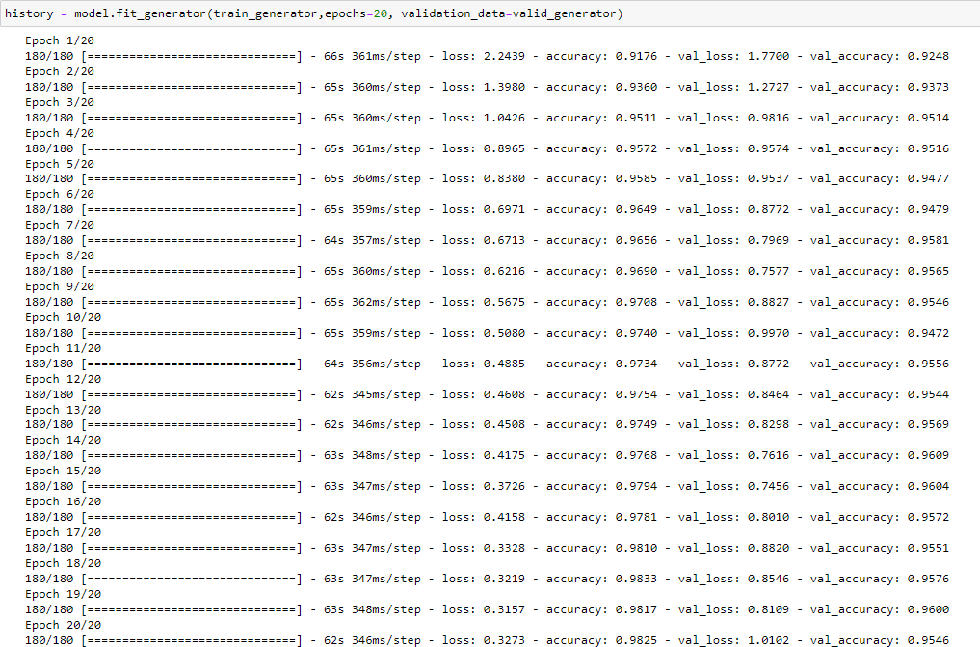

1. **Saving the model:**



1. **Plots for training vs validation accuracies and losses**

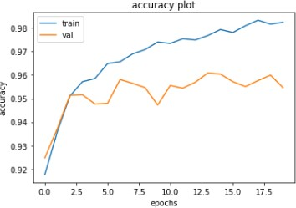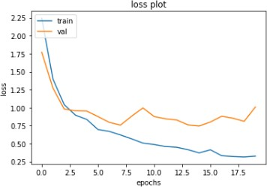

1. **Testing the model with the Test dataset**

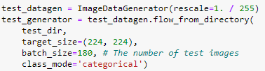

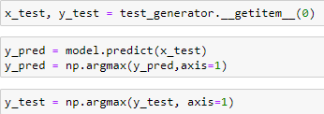

1. 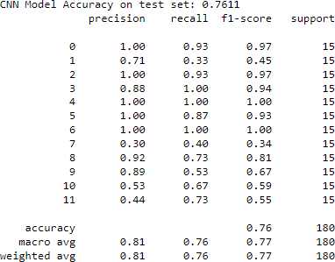**Classification Report with F1 score**
2. 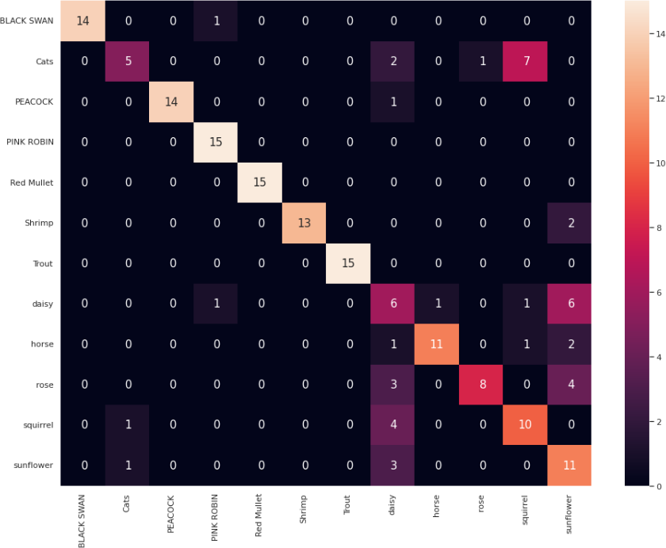**Confusion Matrix**
3. **Model Accuracy after Testing the model**

